# **Overview**

**Members:**

1. Zhantemir Bayzak

Email: 203006@astanait.edu.kz

Student ID: 203006

Role: Leader, Developer (JavaScript, HTML, CSS, Node JS)

1. Adilet Bolatkhan

Email: [203061@astanait.edu.kz](mailto:203061@astanait.edu.kz)

Student ID: 203061

Role: Developer (JavaScript, HTML, CSS, Node JS)

1. Amira Amirzhanova

Email: 203022@astanait.edu.kz

Student ID: 203022

Role: Developer (HTML, CSS, navigation bar, documentation)

1. Nazerke Issayeva ]

Email: [203066@astanait.edu.kz](mailto:203066@astanait.edu.kz)

Student ID: 203066

Role: Developer (HTML, CSS, footer, nav. bar, documentation)

**Communication strategy:**

We decided that we should have online meetings on a daily basis in platforms such as Discord and Microsoft Teams. With the help of tools that these platforms provide, it was comfortable to communicate, discuss and work together.

**Motivation**:

Our motivation to do this project is to upgrade our knowledge and skills in creating websites, and use all tools that we learned on the lectures. Maybe this project will be the first or the next and important step on the way to becoming a web developer. Knowledge in this area is great possibility to get a job in a good IT company and get a good salary. After all, people who have skills in the IT sphere are now in demand.

**High-level project scope**:

Our group decided to create a new website, because it will be more sufficient to meet the criteria. Also, it will be easier to understand what we used to create this website. We thought if we take existed website and re-write it, it would cause a lot of problems, that we will not understand how to fix it.

**Target audience/market**:

People, who are interested in football can use this website for understanding the possible outcomes of the match, also football lovers can calculate the game score precisely.

# **Project goals and team interests**

**Project goals:**

* Create a website that is going to have a score counter, which will help football fans to track the match score.
* Create an understandable interface with the help of navigation bar for easy using.
* Create a server, which hosts all pages the website has.

**Team interests:**

* Improve HTML and CSS skills
* Improve Bootstrap skills
* Understand the website design principles
* Strengthen the communication skills

# **Phases**

**Phases:**

* Phase 1 – Draw a basic skeleton of future website.
* Phase 2 – Highlight the input and output forms and what information our website will hold.
* Phase 3 – Which fonts, images, icons we are going to use.
* Phase 4 – Start the HTML part.
* Phase 5 – Link the CSS part with HTML and style the website
* Phase 6 – Add Bootstrap Grid.
* Phase 7 – Add the calculator.
* Phase 8 – Connect the website to the server.
* Phase 9 – Upload to Github and write the documentation.

# **Content structure**

**Site map**

**Figure-1**

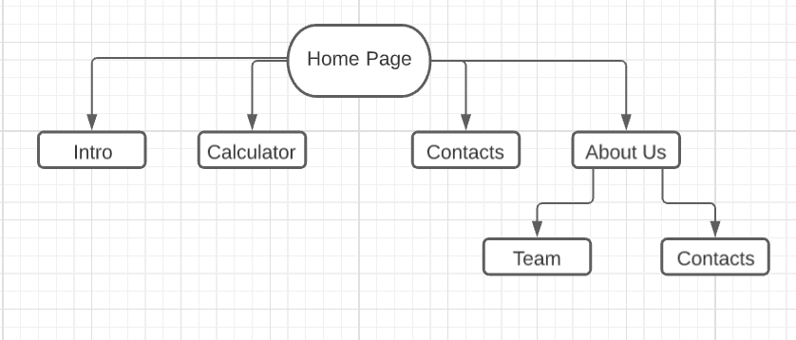

**Content types**

* People
* Events
* Testimonials
* Football
* Fans
* Players

**Design**

Figure-2 and Figure-3 depicts the main page of our website and how everything appears in general.

**Figure-2**

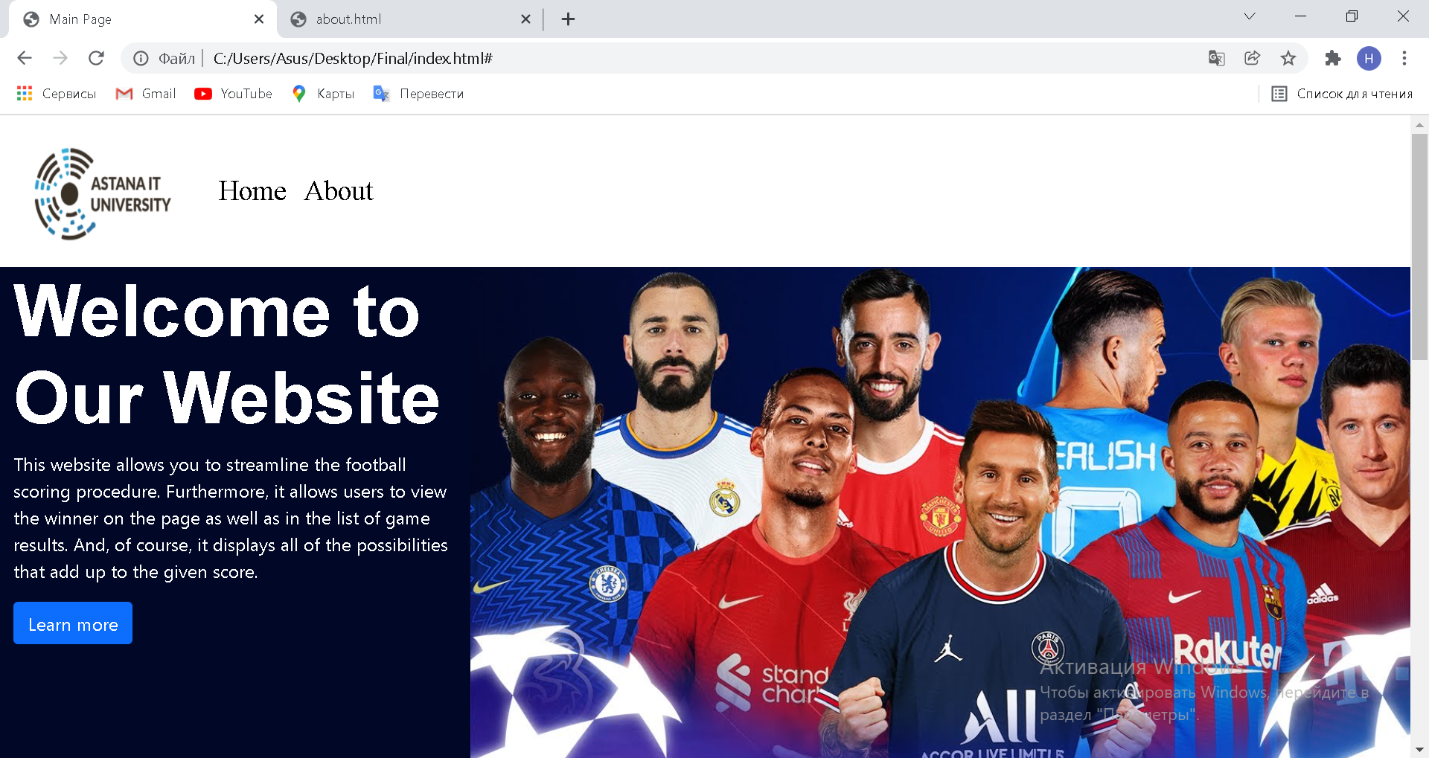

**Figure-3**

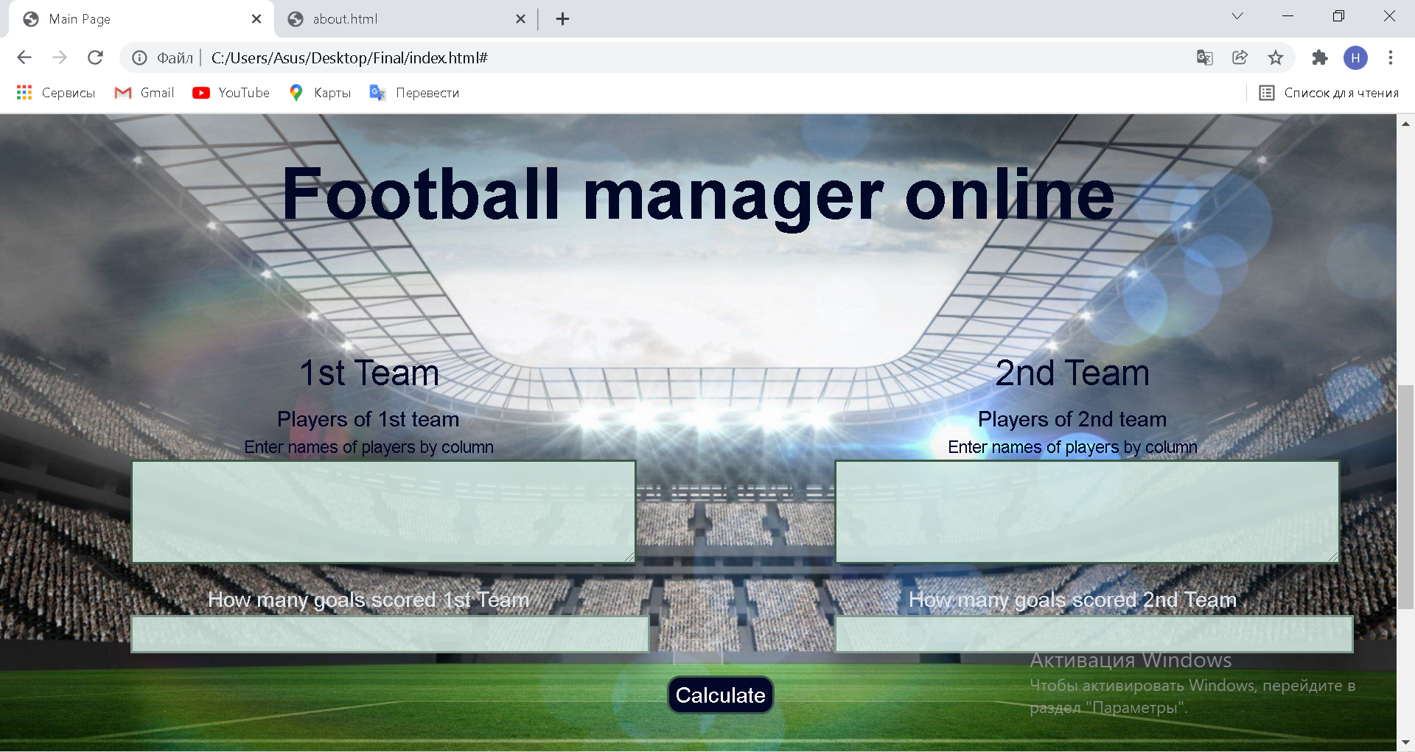

Figures 4 and 5 are filled with information about team members who has done this final project.

**Figure-4**

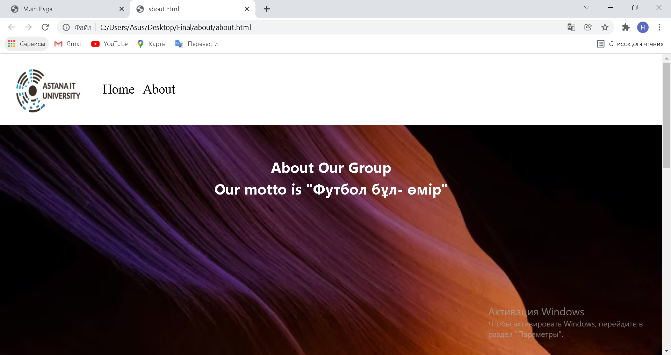

**Figure-5**

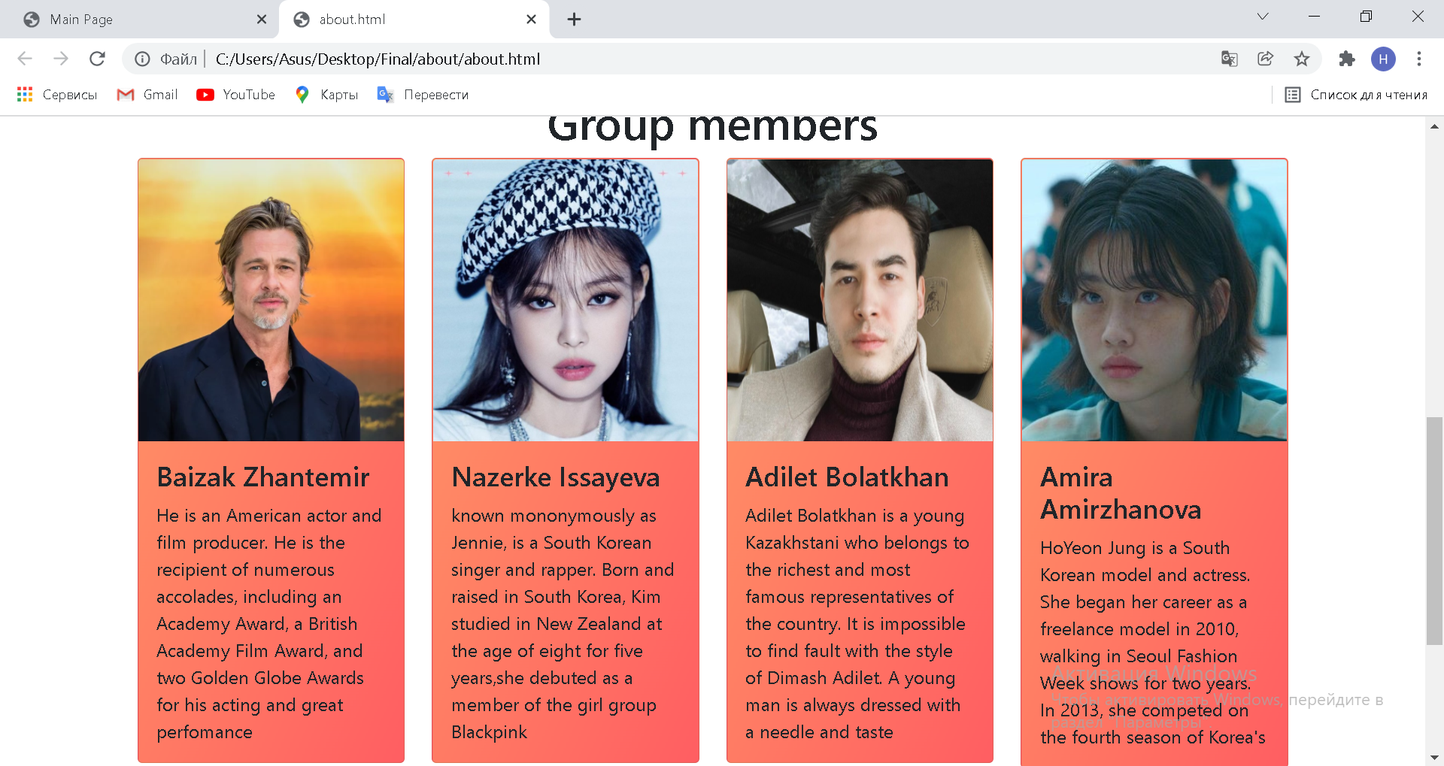

**Functionality**

In Figure-6 you can see the navigation bar of home page. It is intended to see how many external pages our website has.

**Figure-6**



Figure-7 and Figure-8 describe all input textboxes of Team 1 and 2.

**Figure-7**

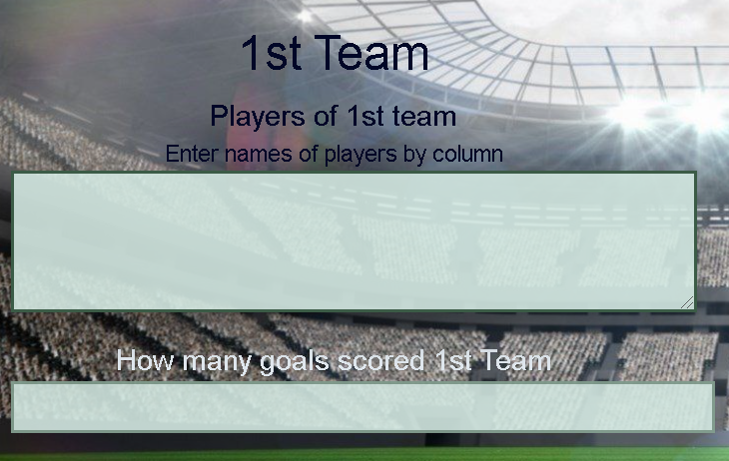

**Figure-8**

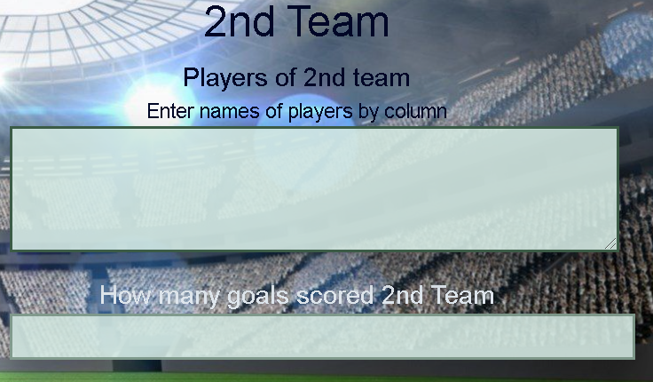

Button “Calculate” in Figure-9 allows us to see how scoring procedure goes in football game.

**Figure-9**

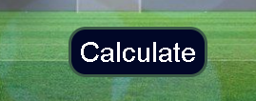

In Figure-10 there is a footer of the website where you can see our contact information, such as phone number, instagram and etc.

**Figure-10**

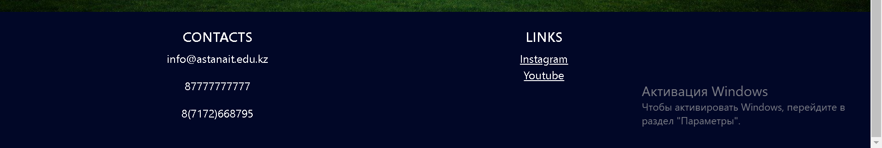

**Hosting**

First of all we sign in to GitHub. Then we create a new repository and after that name it.

Choose a “Public” option, so everyone would see that repository.

Initialize repository by clicking “Add a README file” and click “Create repository”.

After that we are clicking “Add file” and uploading HTML, CSS and photos that we used to create the website and commit changes.

As the next step we go to “Settings”, scroll down to the end and see the “GitHub Pages”.

Choose “main” in source option.

As folder we choose “/docs” and save it.

Finally, we go to the end of the “Settings” page and see the link of our website, that published in GitHub.

**Accessibility**

The project created by Group 6 is clear and accessible for everyone. We have precise and well-working score calculator with understandable interface. Convenient navigation bar helps to not get lost in our pages. Also, we have contact links which will help to contact us.

**Deadlines**

* Phase 1 – November 16, 22:00
* Phase 2 – November 16, 22:00
* Phase 3 – November 17, 22:00
* Phase 4 – November 17, 22:00
* Phase 5 – November 18, 22:00
* Phase 6 – November 18, 22:00
* Phase 7 – November 19, 22:00
* Phase 8 – November 20, 22:00
* Phase 9 – November 20, 22:00
* Phase 10 – November 21, till the deadline

# **Summary**

This project is one of the great and first projects that we did in 10 days. Each member of the group gained something new from this work and improved his skills that will be useful in future studying or working.

We had a lot of challenging moments such as collecting pages, that we divided between group members, also some coding parts were difficult to implement correctly.

In conclusion, starting something new is always a good idea and improving yourself in different areas is also great. We tried hard and did a good job to provide a great website for people that will use it. We guess that we achieved project goals and team interests, because we had so many mistakes and we were trying to correct them thinking about principles of creating website. This project work has boosted the skills of each member. We gained a lot of practice knowledge, which is more efficient than theoretical one. This project also gave us an opportunity to improve our negotiation skills as we were interacting with ourselves.

“Web technologies” course has covered all necessary topics, which will be helpful in our future. This course has taught us from basics to advanced features, such as hosting a server.